“A” Activity
Island Hopping!
A hot spot is an area of concentrated heat, deep within the Earth’s interior. Hot spots melt the rocks of the mantle, which creates a column of magma that rises toward the surface. Examine the map of the Hawaiian Islands below. The first map shows the ages of the rock on the islands. Please TYPE each of your COMPLETE answers.
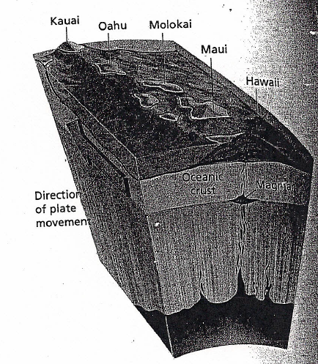
Questions:
- Use the map and your knowledge of the theory of plate tectonics to explain how the Hawaiian Islands might have formed.
- Which islands are the oldest and how can you tell?
- Do you think any new islands will form? Why?
- Which islands are most likely to have active volcanoes? Explain.

